Preparing the Active Directory

# Notes prep

* ADprep

# Update the Schema if needed

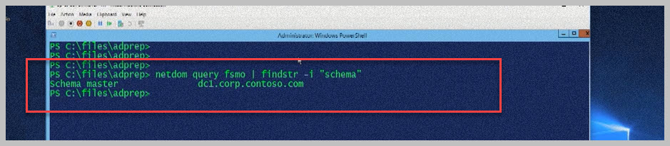

# Running ADPrep

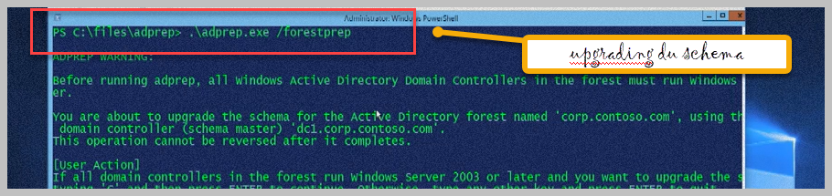

# Verify the schema vesion

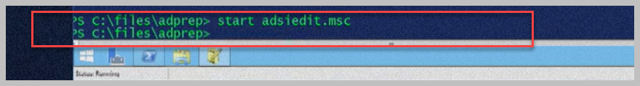

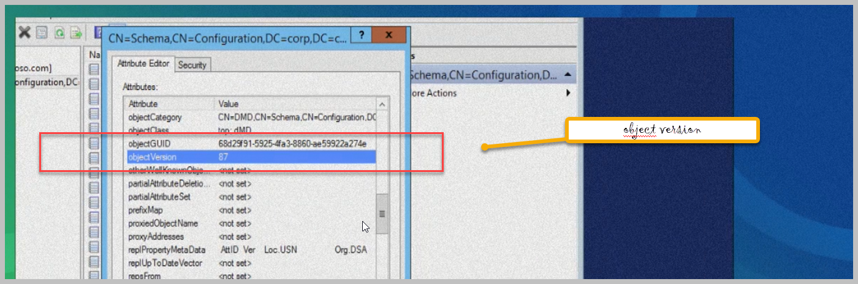

# MsDS-keyCredentialLink

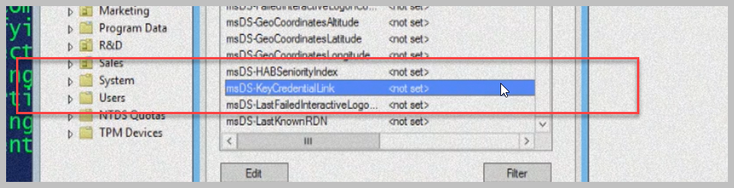

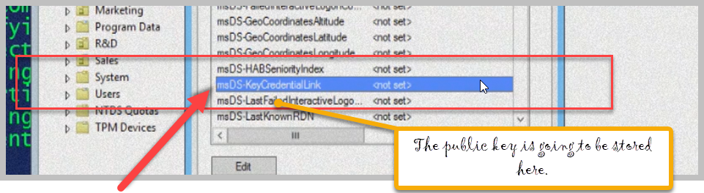

We can have mutliple key here.

# Creating Group for key assignation

